Week 3 - Data Communication
Name : Swayam Rudrawar

Objective
To enable device-to-device and device-to-cloud communication using ESP32, ThingSpeak and MQTT.

Project 1: Device-to-Cloud Communication
DHT22 sensor data was transmitted from ESP32 to the ThingSpeak cloud platform using HTTP requests over Wi-Fi.
Architecture: DHT22 → ESP32 → Wi-Fi → ThingSpeak Cloud Dashboard
DHT22 Pin | ESP32 Pin
VCC | 3.3V
GND | GND
DATA | GPIO15

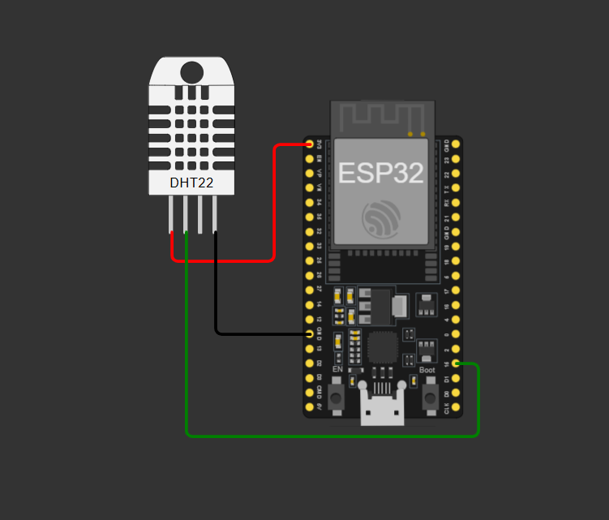
Code:-
#include <WiFi.h>
#include <HTTPClient.h>
#include "DHTesp.h"

const char* ssid = "Wokwi-GUEST";
const char* password = "";

const char* apiKey = "GVFPDOANEIGYQK3C";

DHTesp dht;

void setup() {

Serial.begin(115200);

dht.setup(15, DHTesp::DHT22);

WiFi.begin(ssid, password);

Serial.print("Connecting");

while (WiFi.status() != WL_CONNECTED) {
delay(500);
Serial.print(".");
}

Serial.println();
Serial.println("WiFi Connected");
}

void loop() {

TempAndHumidity data = dht.getTempAndHumidity();

float temp = data.temperature;
float hum = data.humidity;

Serial.print("Temperature: ");
Serial.println(temp);

Serial.print("Humidity: ");
Serial.println(hum);

if (WiFi.status() == WL_CONNECTED) {

HTTPClient http;

String url =
"https://api.thingspeak.com/update?api_key=" +
String(apiKey) +
"&field1=" +
String(temp) +
"&field2=" +
String(hum);

http.begin(url);

int responseCode = http.GET();

Serial.print("Response Code: ");
Serial.println(responseCode);

http.end();
}

delay(20000);
}
Output:-

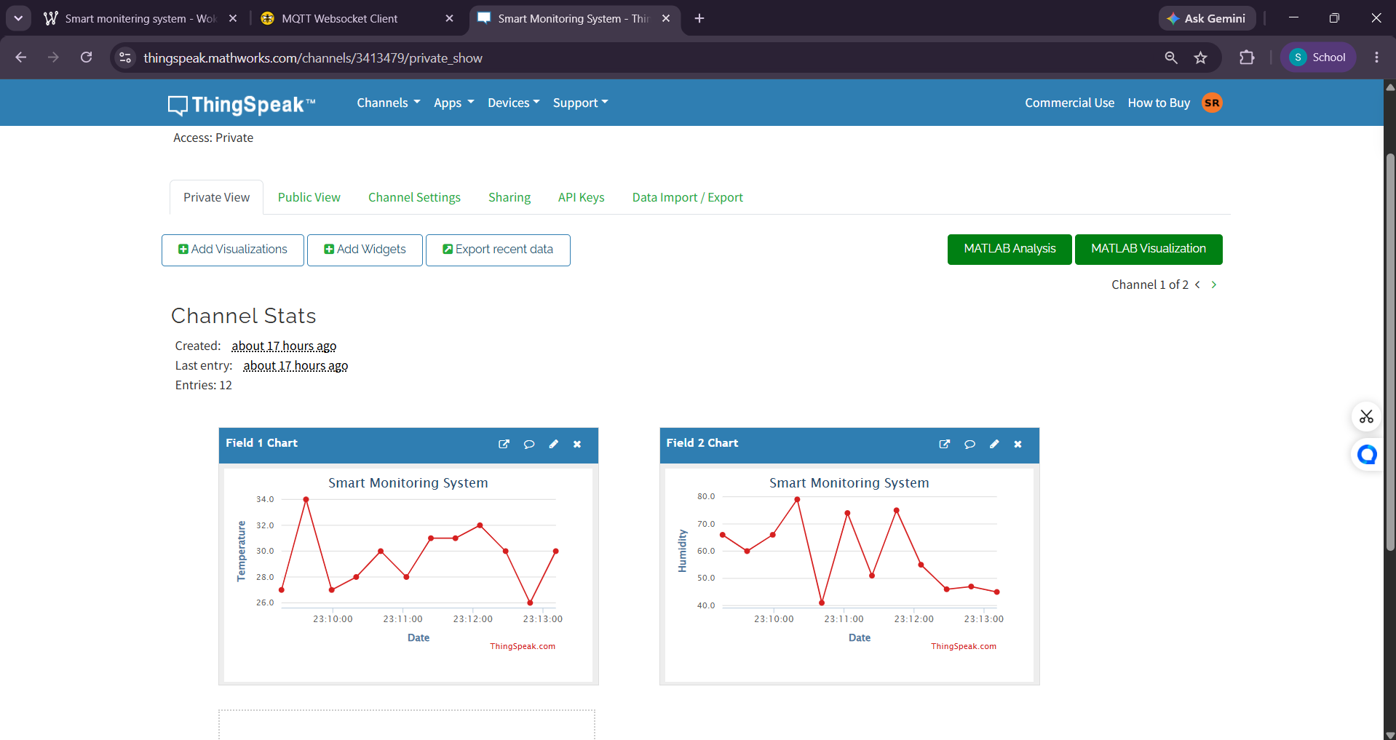

Project 2: Device-to-Device Communication
MQTT communication was implemented using an ESP32 publisher and HiveMQ MQTT broker.
Architecture: ESP32 Publisher → MQTT Broker → Subscriber Client
Topic | Purpose
swayam/arnita/temperature | Temperature Data
swayam/arnita/humidity | Humidity Data

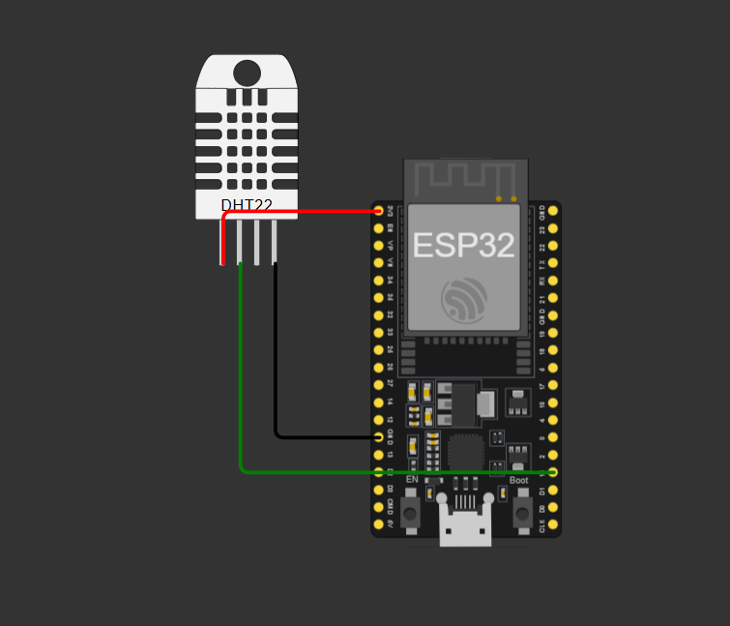
Code:-
#include <WiFi.h>
#include <PubSubClient.h>
#include <DHT.h>

#define DHTPIN 15
#define DHTTYPE DHT22

const char* ssid = "Wokwi-GUEST";
const char* password = "";

// MQTT Broker
const char* mqtt_server = "broker.hivemq.com";

WiFiClient espClient;
PubSubClient client(espClient);

DHT dht(DHTPIN, DHTTYPE);

void reconnect() {

Serial.println("Inside reconnect()");

while (!client.connected()) {

Serial.print("Connecting to MQTT...");

if (client.connect("ESP32_Publisher")) {

Serial.println(" Connected!");

} else {

Serial.print(" Failed, rc=");
Serial.println(client.state());

delay(2000);
}
}
}

void setup() {

Serial.begin(115200);
delay(1000);

Serial.println("================================");
Serial.println("MQTT Publisher Started");
Serial.println("================================");

dht.begin();
Serial.println("DHT22 Initialized");

Serial.print("Connecting to WiFi");

WiFi.begin(ssid, password);

while (WiFi.status() != WL_CONNECTED) {
delay(500);
Serial.print(".");
}

Serial.println();
Serial.println("WiFi Connected!");

Serial.print("IP Address: ");
Serial.println(WiFi.localIP());

client.setServer(mqtt_server, 1883);

Serial.println("MQTT Server Configured");
}

void loop() {

if (!client.connected()) {
reconnect();
}

client.loop();

float temperature = dht.readTemperature();
float humidity = dht.readHumidity();

if (isnan(temperature) || isnan(humidity)) {

Serial.println("DHT Read Failed!");

} else {

String tempStr = String(temperature, 2);
String humStr = String(humidity, 2);

bool tempStatus =
client.publish("swayam/arnita/temperature",
tempStr.c_str());

bool humStatus =
client.publish("swayam/arnita/humidity",
humStr.c_str());

Serial.println("--------------------------------");

Serial.print("Temperature: ");
Serial.println(tempStr);

Serial.print("Humidity: ");
Serial.println(humStr);

Serial.print("Temperature Publish Status: ");
Serial.println(tempStatus);

Serial.print("Humidity Publish Status: ");
Serial.println(humStatus);
}

delay(5000);
}

Output:-

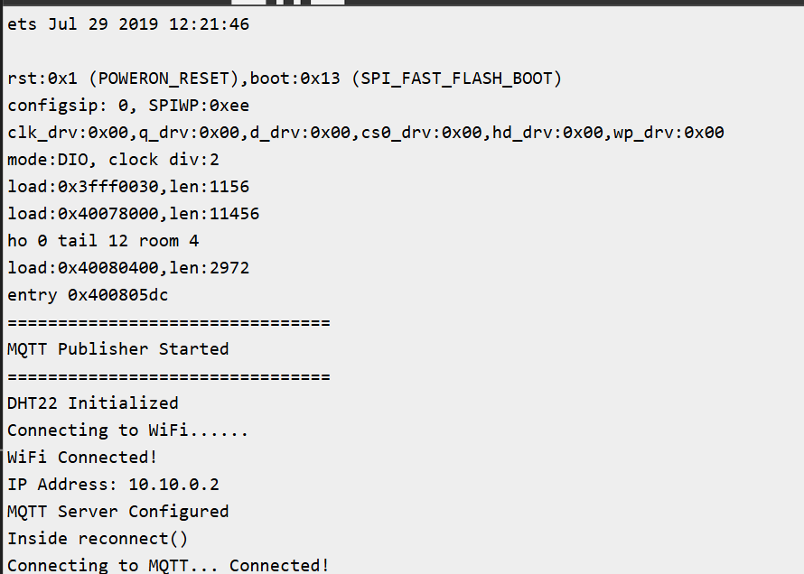
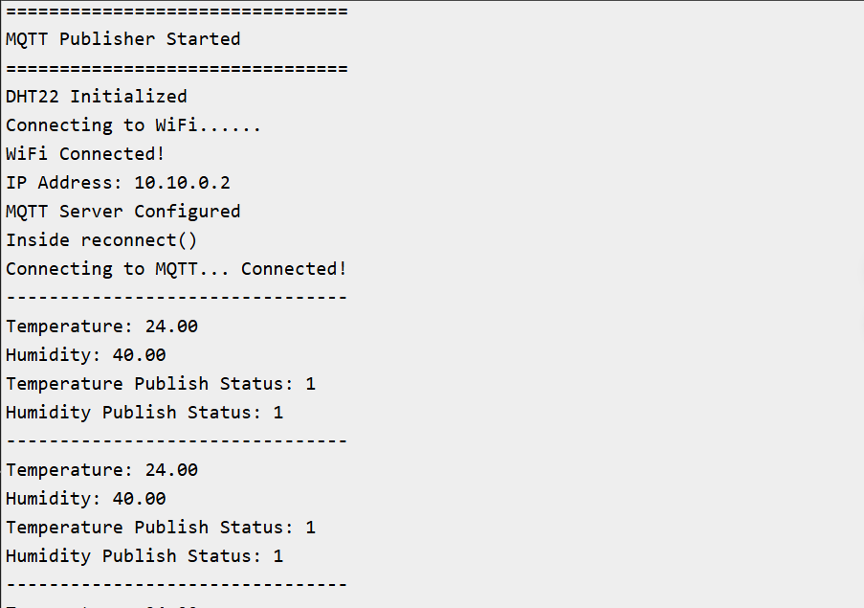
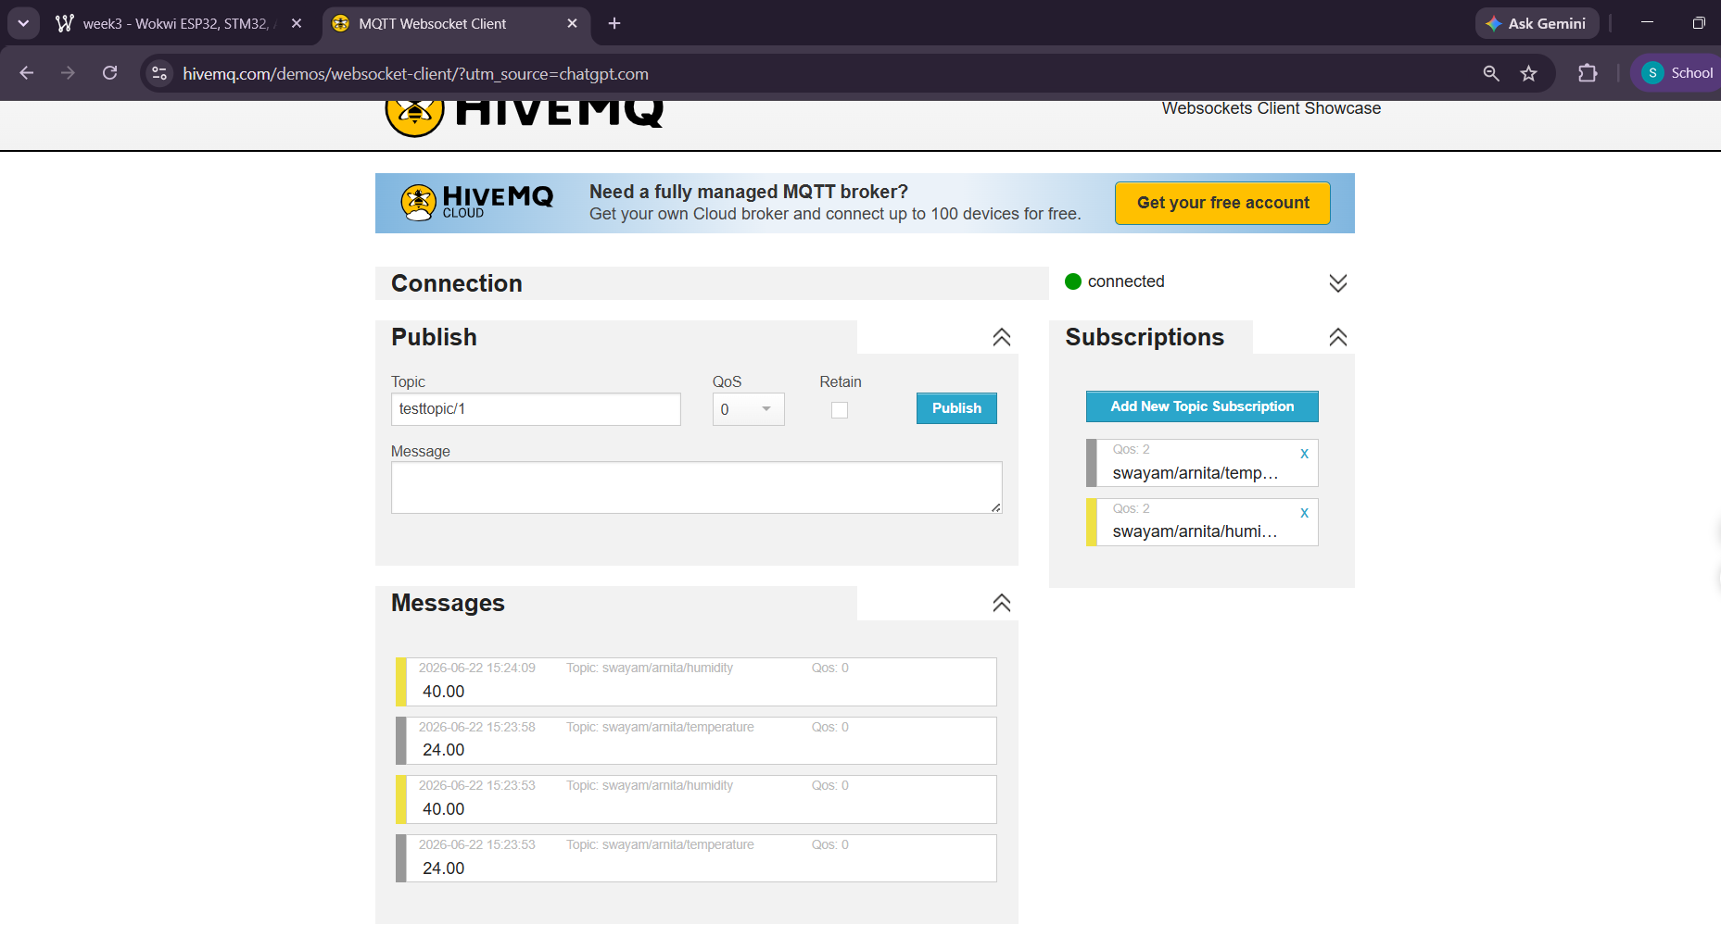

Communication Protocol Comparison
Protocol | Type | Speed | Internet | Application
HTTP | Client-Server | Moderate | Yes | ThingSpeak
MQTT | Publish-Subscribe | High | Yes | Device Communication
Bluetooth | Peer-to-Peer | Moderate | No | Short Range Communication

Observations
ESP32 successfully connected to Wi-Fi.
ThingSpeak displayed live temperature and humidity data.
MQTT enabled real-time communication between publisher and subscriber.
Data transmission was reliable and continuous.

Conclusion
Week 3 objectives were successfully achieved using ThingSpeak and MQTT communication.

